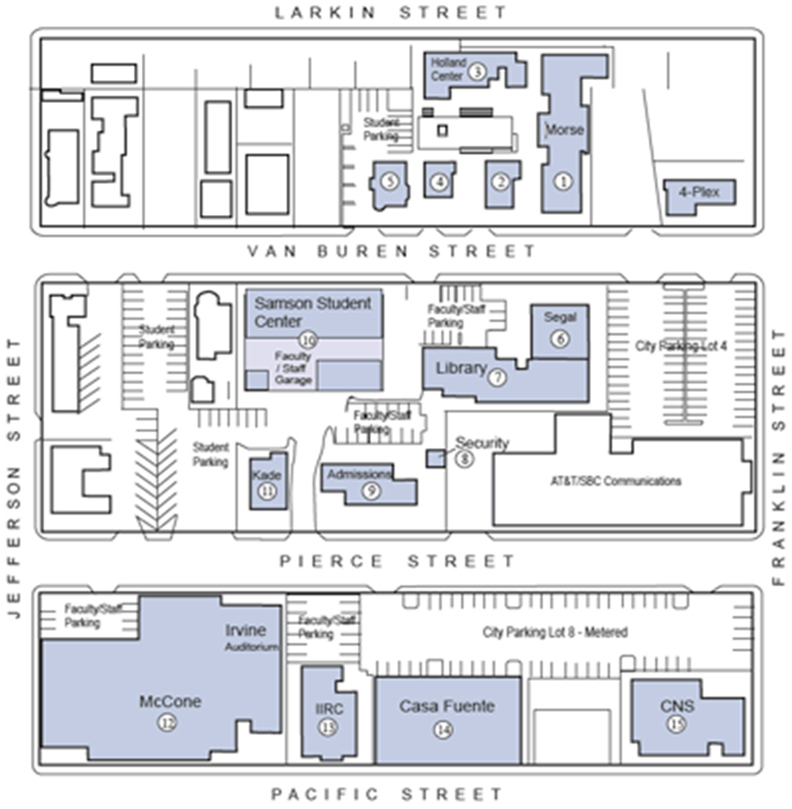

McCone Bldg.

Entrance

Parking